August 31, 2015

Parents of Advanced Math Students,

I will be your child’s teacher for the 5th Grade Advanced Math program this school year. I enjoy teaching this class and look forward to working with your child.

This year, District 25 5th Grade Advanced Math classes will be starting a new curriculum, after many years of working with Everyday Math. We will be transitioning to Big Ideas math, along with the middle schools. There will be a hard-bound student edition, along with a consumable workbook. I am looking forward to trying out Big Ideas, expecting both some excitement and frustrations that come along with any major change.

Please feel free to contact me if you have any questions regarding any of the concepts that we will be covering. Please let your child, as much as possible, complete any homework on their own, and step in only if they seem lost. I have let the students know that they will be permitted to turn in incomplete homework with a parent note explaining (otherwise they are always expected to turn it in on time). Help at home might come in the form of extra needed work on “expected” number operations.

Today we covered the following expectations for the class:

1) Come prepared every day. Bring HW and materials without
reminders.
2) Expect to have math homework most days. I like to give
weekends off whenever possible.
3) Be strong with your multiplication and division facts. We
will rely on them heavily. This may require extra practice at
home.

4) Work hard and ask questions. Always let me know when
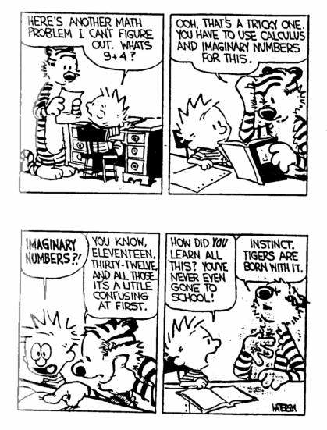
you don’t understand something.
5) Don’t be afraid to make mistakes. They are expected and we can learn a lot from our mistakes.

You can reach me by email at tmorkert@sd25.org . My voicemail number is 847-506-6999 (x7946), though email is preferable as I am more easily able to check and respond.

Sincerely,
Tim Morkert

